Machine Problem (Python): Problem 5

Python Script

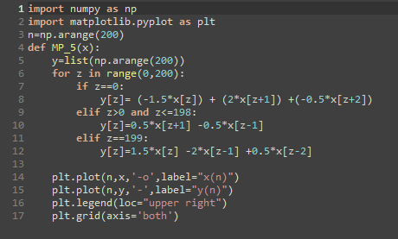

Setting up input (x)

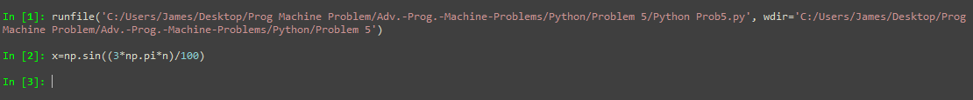

Output plot of program

